**Game Statement: FIFA HEX**

คุณและเพื่อนของคุณคือผู้ที่ถูกที่คัดเลือกในการแข่งขันเพื่อเฟ้นหาผู้ที่มีความเป็นเลิศในเรื่องแผนการเล่นของทีมฟุตบอลเพื่อมาเป็นโค้ชฝ่ายแผนการเล่นให้กับทีมและนำพาความสำเร็จมาสู่ทีม แต่ตำแหน่งโค้ชฝ่ายแผนการเล่นมีได้เพียงคนเดียว การประลองเพื่องานที่คุณใฝ่ฝันมาทั้งชีวิต และศักดิ์ศรีการเป็นผู้รอบรู้ทางด้านฟุตบอลจึงได้เริ่มต้นขึ้น

**How To Play?**

1. ในแต่ละตาที่ผู้เล่นได้เล่นนั้น ผู้เล่นสามารถเลือกทำอย่างใดอย่างหนึ่งใน 3 อย่างคือ **วางหมากในสนาม,** **เคลื่อนหมากในสนาม** หรือ **ใช้ความสามารถพิเศษ**
2. การวางหมากในสนาม ในแต่ตาผู้เล่นสามารถเลือกวางหมากได้ 1 ตัว

โดยการวางหมากนั้นคุณจะต้องวางติดกับหมากฝั่งตัวเองเท่านั้น

1. การเคลื่อนหมากในสนาม หมากของผู้เล่นแต่ละตัวจะมีรูปแบบการเดินที่แตกต่างกันไป แต่ทุกการเคลื่อนหมากจะ**ต้องไม่ทำให้หมากแบ่งเป็น 2 กลุ่ม** โดยการเดินหมากแต่ละตำแน่งมีดังนี้

3.1 หมากกองหน้า(Attacker) จะเดินข้ามแนวหมากที่เป็นแนวเส้นตรงกับ ตัวเองดังรูป

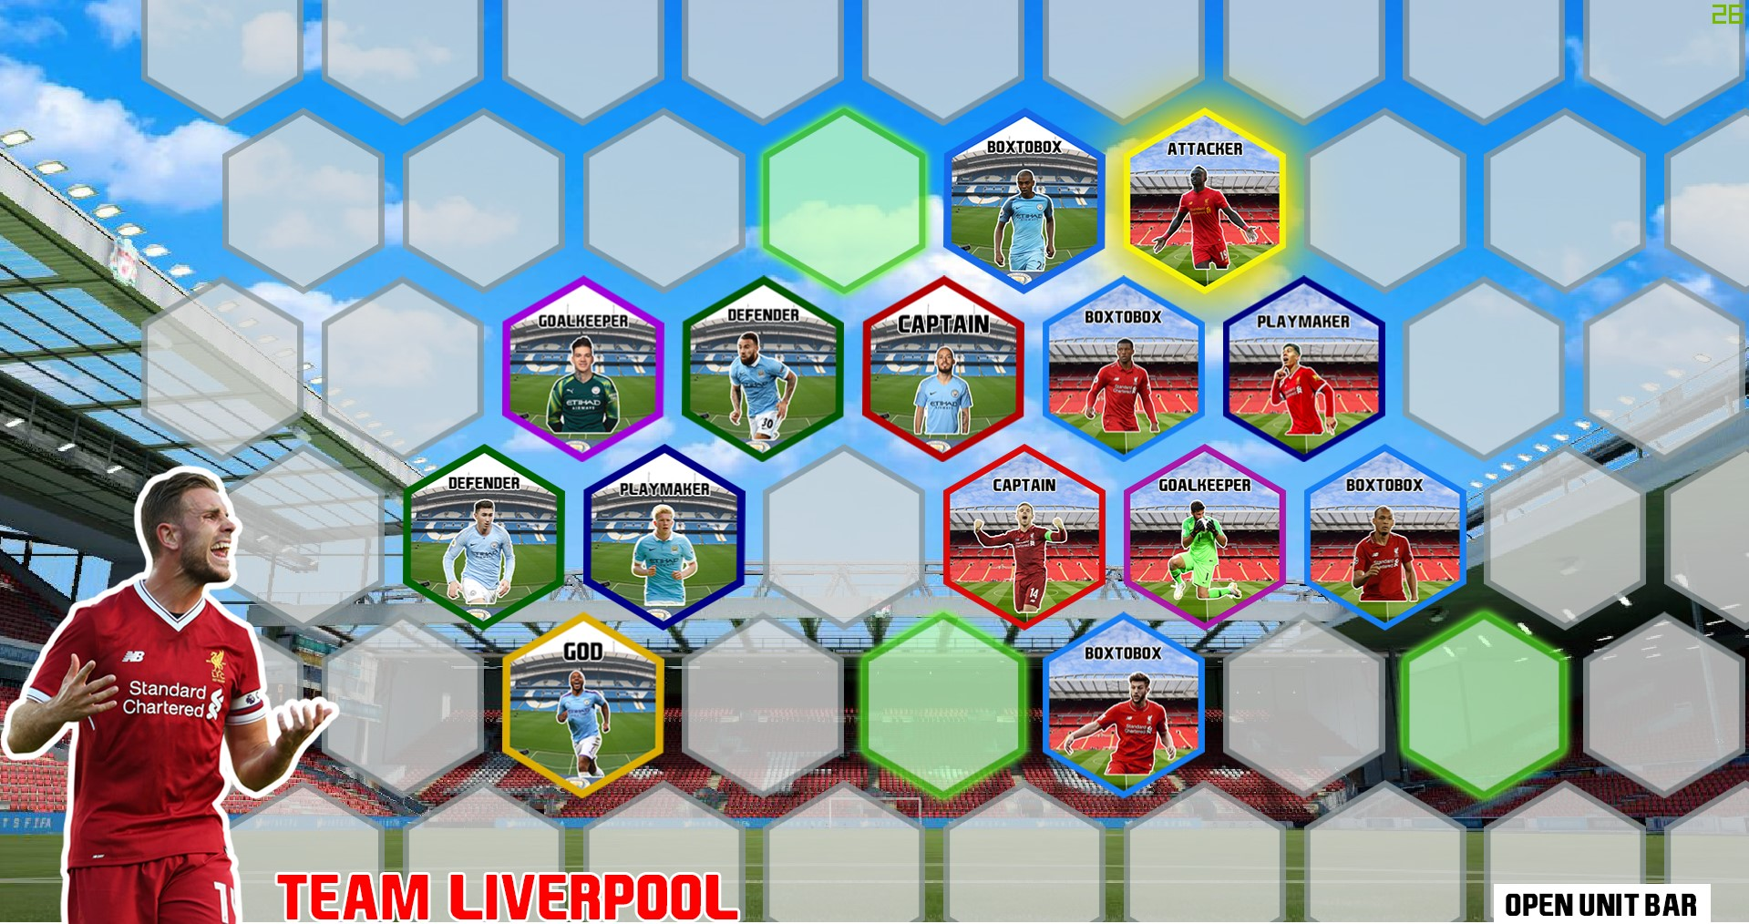

รูปภาพที่ 1: การเดินของหมากกองหน้า(Attacker)

3.2 หมากกองกลาง(BoxtoBox) สามารถวิ่งได้ทั่วสนาม ยกเว้นจุดที่หมากตัวนั้นไม่สามารถเลื่อนเข้าได้ ดังรูป

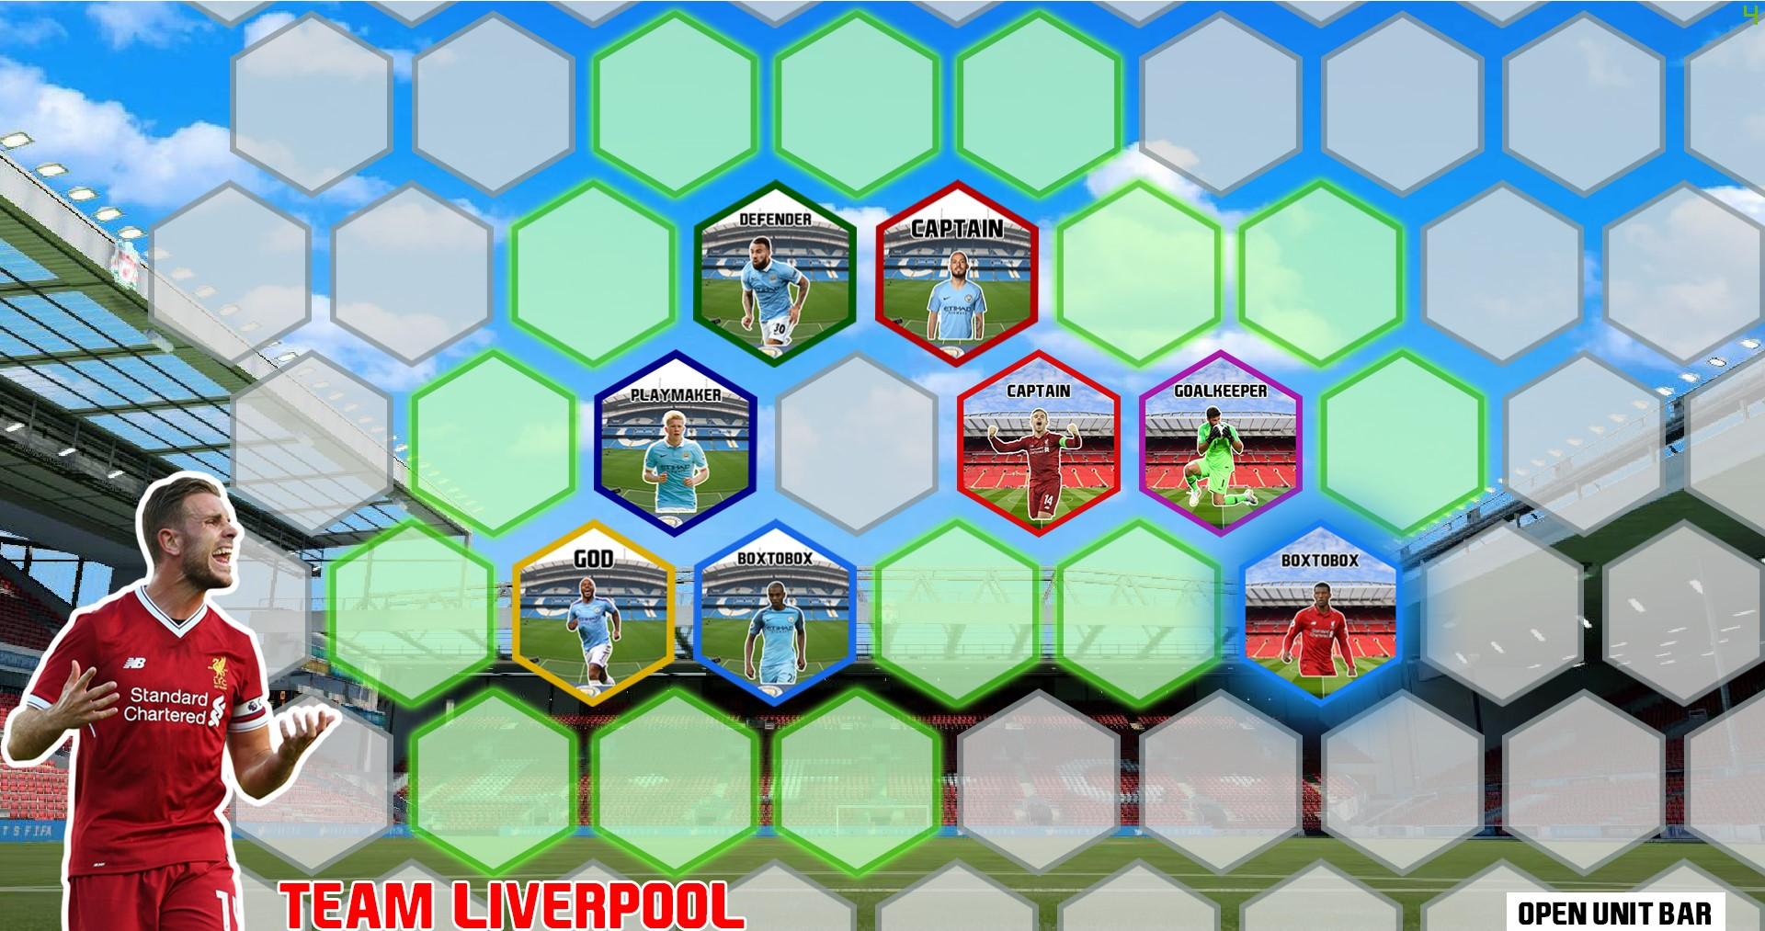

รูปภาพที่ 2: การเดินของหมากกองกลาง(ฺBoxtoBox)

3.3 หมากกองหลัง(Defender) วิ่งได้ 1 ช่อง และสามารถเดินทับหมากตัวอื่นได้ (ยกเว้นหมากกัปตัน ManUnited)

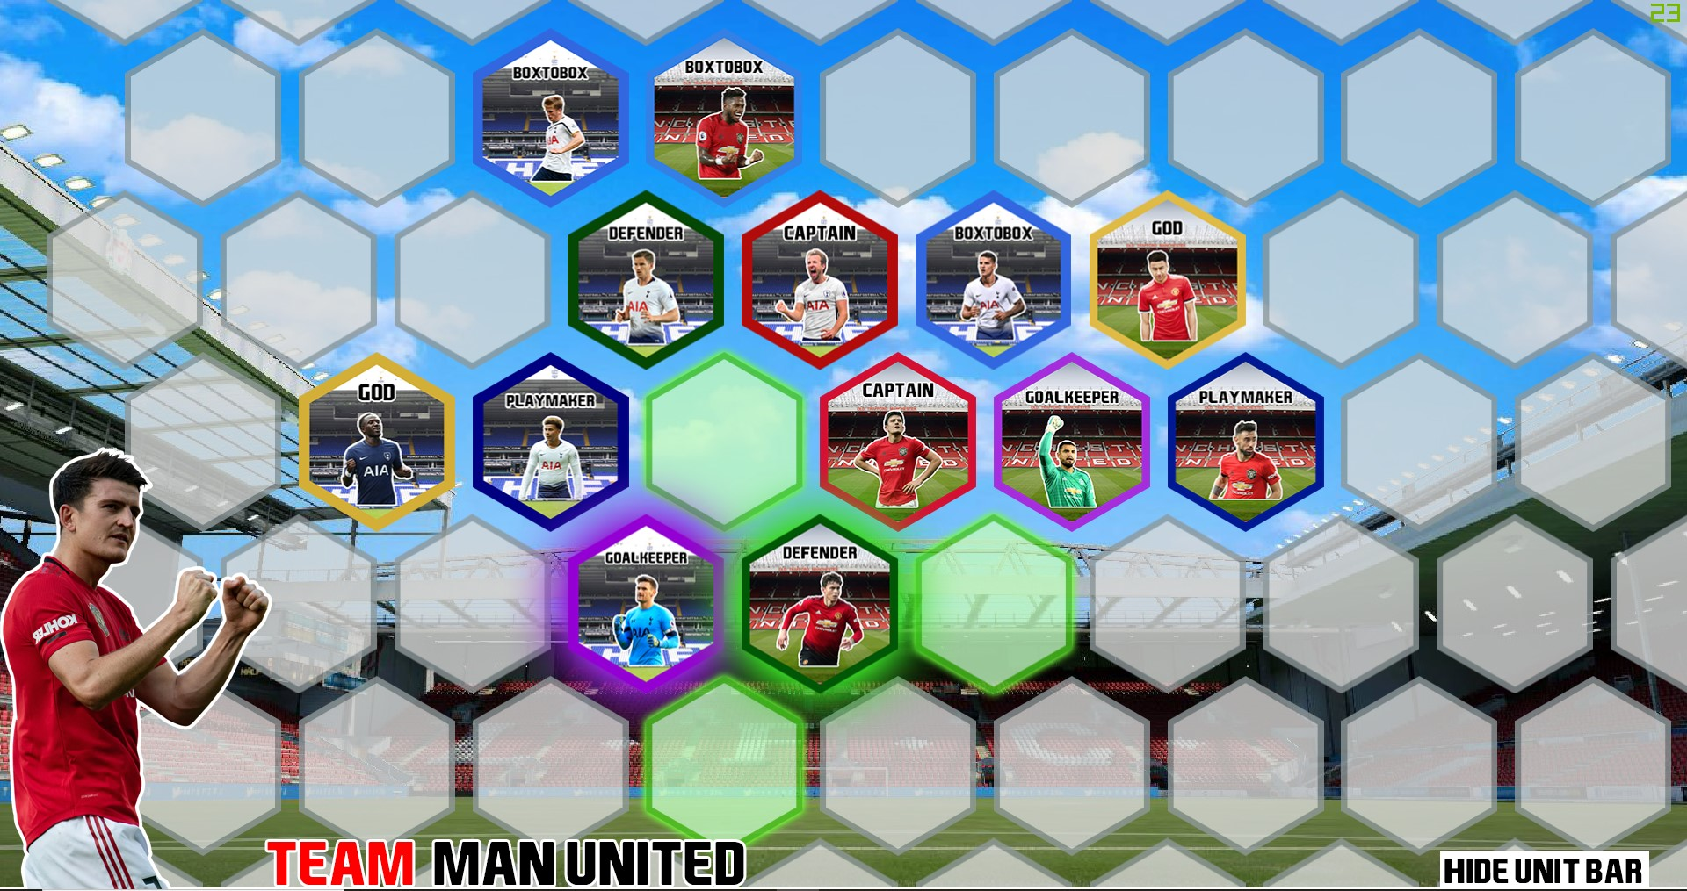

รูปภาพที่ 3: การเดินของหมากกองหลัง(ฺDefender)

3.4 หมากกองกลางตัวรุก(Playmaker) บังคับให้เดิน 3 ช่อง โดยเดินบนหมากตัวอื่น 2 ตัว และต้องลงมายังช่องว่าง

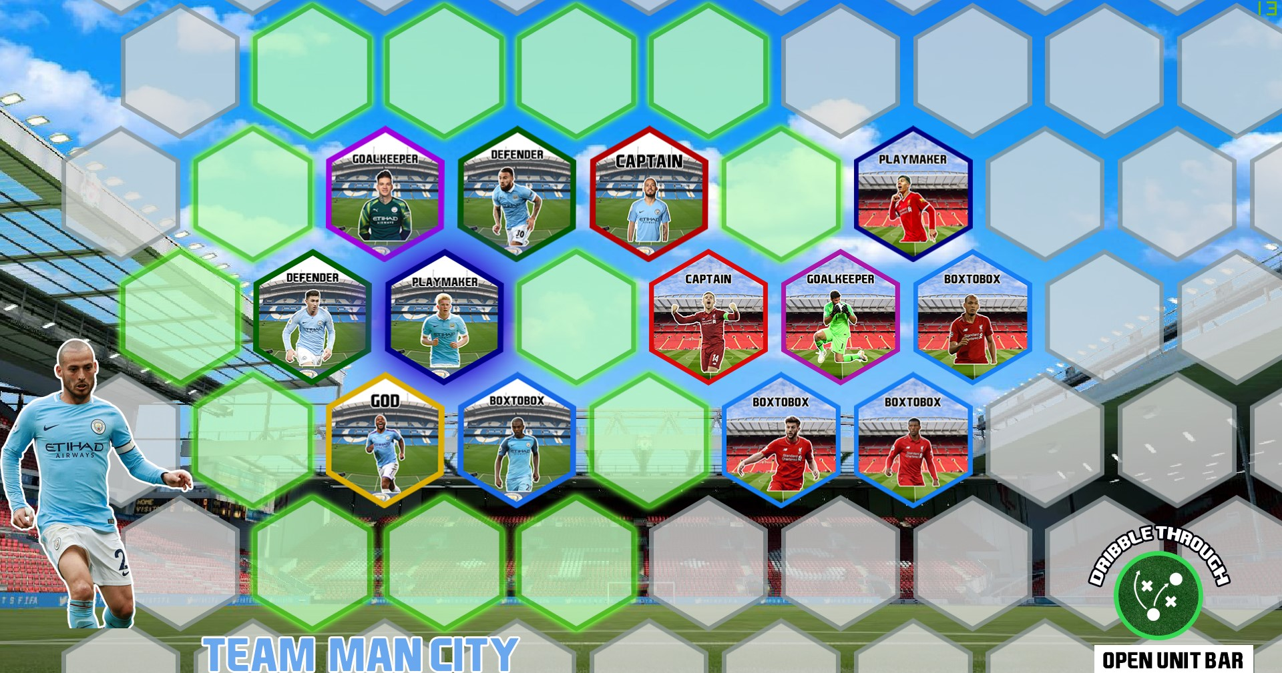

รูปภาพที่ 4: การเดินของหมากกองกลางตัวรุก(Playmaker)

3.5 หมากผู้รักษาประตู(Goalkeeper) บังคับให้เดิน 3 ช่องเท่านั้น

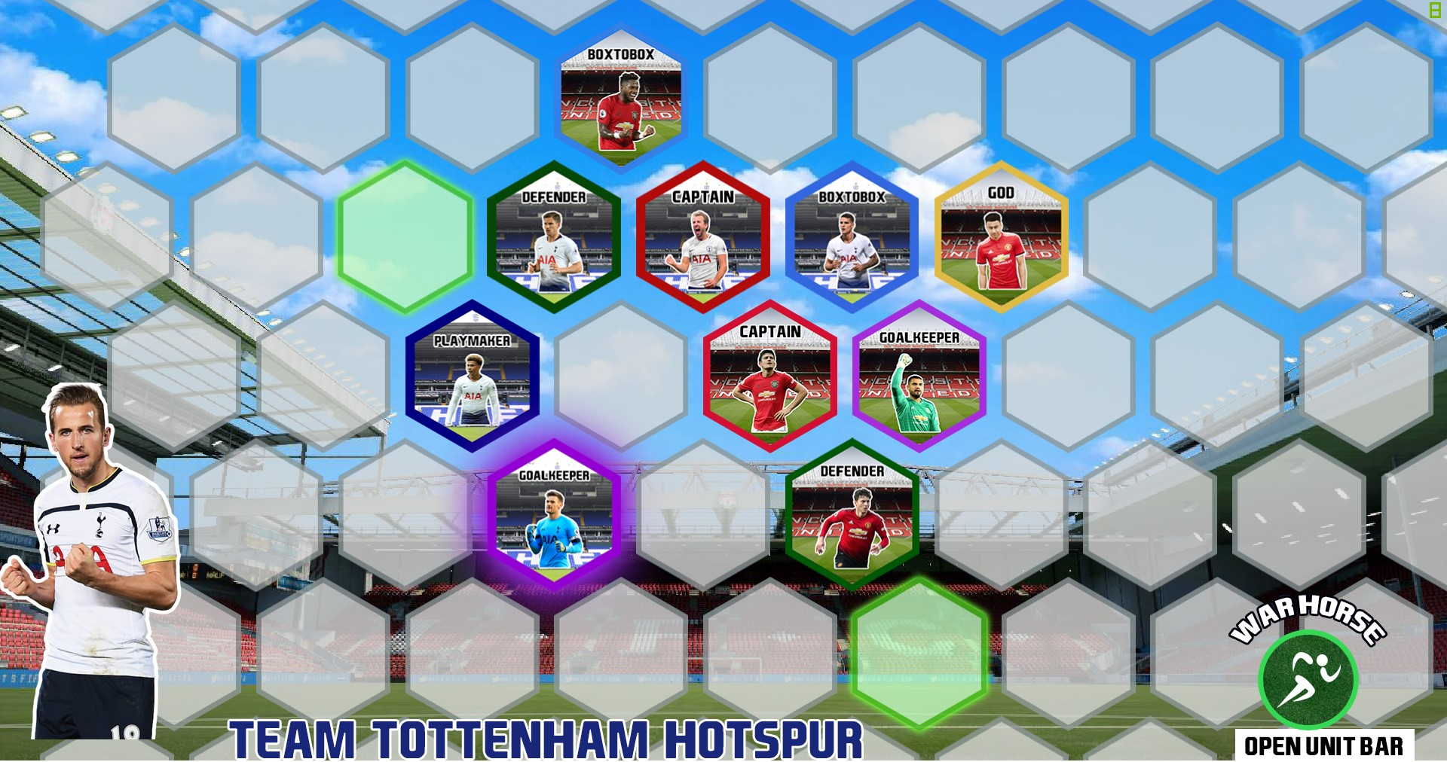

รูปภาพที่ 5: การเดินของหมากผู้รักษาประตู(Goalkeeper)

3.6 หมากผู้เล่นเทพเจ้า(God) จะสุ่มรูปแบบการเดินเมื่อถูกวางลงบนกระดาน และจะยึดรูปแบบนั้นไปทั้งเกม โดยรูปแบบที่เป็นไปได้มี 4 รูปแบบ คือ **หมากกองหน้า(Attacker), หมากกองกลาง(BoxtoBox), หมากกองกลางตัวรุก(Playmaker)** และ **หมากผู้รักษาประตู(Goalkeeper)**

1. ใช้ความสามารถพิเศษ หมากกัปตันแต่ละทีมจะมีความสามารถพิเศษหรือการเดินหมากที่ต่างกันไป

* หมากกัปตัน Liverpool : จะเดินได้ 1-2 ช่อง
* หมากกัปตัน ManUnited : เดินได้ 1 ช่อง แต่จะไม่ถูก **หมากกองหลัง(Defender)** เดินทับได้
* หมากกัปตัน ManCity : เดินได้ 1 ช่อง และมี skill: dribble ที่ถ้าถูกกองหลังทับอยู่จะสามารถเคลื่อนออกมายังช่องว่างข้างๆได้
* หมากกัปตัน Spur : เดินได้ 1 ช่อง และมี skill: warhorse ที่จะสามารถเคลื่อนที่ได้ทั่วสนามและสลับที่กับหมากตัวอื่นด้วย แต่สามารถใช้ skill นี้ได้แค่ 1 ครั้งต่อเกม

1. การที่จะชนะในเกมนี้ได้ ผู้เล่นต้องนำหมาก **ล้อมหมากกัปตัน** ฝั่งตรงข้าม อีกทั้งต้องพยายามไม่ให้ฝั่งตรงข้ามนำหมากมาล้อม **หมากกัปตัน** ของคุณด้วย โดยหมากที่ล้อมนั้นจะเป็นหมากของผู้เล่นฝั่งใดก็ได้

**Implement Detail**

Noted that Access Modifier Notations can be listed below

* **+ (public)**
* **# (protected)**
* **- (private)**
* **final** will be bold.
* static will be underlined.
* *abstract* will be italic.

1. **package** logic

1.1 **class** Owner

1.1.1 Fields

|  |  |
| --- | --- |
| - String name | store name of player/owner. |
| - boolean placeCaptain | store that owner already place captain. |
| - Team team | store team that player/owner owned. |

1.1.2 Constructors

|  |  |
| --- | --- |
| + Owner(String teamName) | initialize new player/owner. |

1.1.3 Methods

|  |  |
| --- | --- |
| + String getName() | getter/setter for each field. |
| + Team getTeam() |
| + boolean isPlaceCaptain() |
| + void setName(String name) |
| + void setTeam(Team team) |
| + void setPlaceCaptain(boolean placeCaptain) |

1.2 **class** Sprites

This class use only store sprites number for each type of unit.

1.3 **class** GameBoard

1.3.1 Fields

|  |  |
| --- | --- |
| - **int INF** | set infinity cap by 1000000000. |
| - int height | store the height of the board. |
| - int width | store the width of the board. |
| - ArrayList<ArrayList<Unit>> units | store each unit in the board in 2 dimensions. |

1.3.2 Constructors

|  |  |
| --- | --- |
| + GameBoard() | setup the board and initialized. |
| + GameBoard(int width, int height) |

1.3.3 Methods

|  |  |
| --- | --- |
| + void InitializedBoard() | initailized the board. |
| + void printBoard() | print out the board in sprites number. |
| + void addUnit(Unit unit, int x, int y) | add new unit to the board in (x, y) position. |
| + void placeUnit(Unit unit, int x, int y, Owner owner) | place new unit and assign new owner. |
| + void moveUnit(int x1, int y1, int x2, int x2, Owner Owner) | move unit from position (x1, y1) to (x2, y2). |
| + ArrayList<Unit> getAdjacentUnit(int x, int y) | get unit that adjacent to position (x, y). |
| + ArrayList<ArrayList<Integer>> getDistance(int x, int y, boolean isThrough) | get distance from postion (x, y) to everywhere on the board. (Bellman-Ford) |
| + boolean checkGameBoard() | check that every unit on the board are connected. |
| + ArrayList<Unit> getOwnerUnit(Owner owner) | get every unit on the board that owned by player/owner. |
| + boolean isUnitMovable(int x, int y) | check that unit in position (x, y) can move or not. |
| + boolean isEmpty(int x, int y) | check that in position (x, y) is empty or not. |
| + Unit getUnit(int x, int y) | get unit in position (x, y). |
| + int getWidth() | getter for width and height. |
| + int getHeight() |

1.4 **class** GameController

1.4.1 Fields

|  |  |
| --- | --- |
| + GameBoard gameBoard | store the board of the game. |
| + boolean gameEnd | store that the game is end or not. |
| + Owner player1 | store player 1. |
| + Owner player2 | store player 2. |
| + int turn | store the number of the turn. |

1.4.2 Methods

|  |  |
| --- | --- |
| + void InitializeGame(String team1, String team2, int positionUnit1, int positionUnit2) | Initialized the game for playing. |
| + void printBoard() | print the board in sprites number. |
| + void setupFirstPick(Unit unit1, Unit unit2) | setup the first pick on the board for each player/owner. |
| + void setupTeamPick(String team1, String team2) | setup team pick for each player/owner. |
| + void placeNewUnit(int position, int x, int y) throw UnitPlaceException | place new unit on position (x, y) on the board. |
| + ArrayList<Unit> getNextPlace() | get position on the board that can place. |
| + void moveUnit(int x1, int y1, int x2, int y2) throw UnitMoveException | move unit from position (x1, y1) to (x2, y2). |
| + Owner getCurrentPlayer() | get player that can play in this turn. |
| + void nextTurn() | switch a turn. |
| + boolean isGameEnd() | check that the game is end or not. |
| + Owner getWinner() | check that who the winner by condition. |
| + void main(String[] args) | (only for test in console game mode)  play the game. |

2. **package** logic.exception

2.1 **class** UnitPlaceException

2.1.1 Fields

|  |  |
| --- | --- |
| - String errorMessage | store error message. |

2.1.2 Constructors

|  |  |
| --- | --- |
| + UnitPlaceException(String errorMessage) | initialize new error. |

2.1.3 Methods

|  |  |
| --- | --- |
| + String getErrorMessage() | getter/setter for error message. |
| + void setErrorMessage(String errorMessage) |

2.2 **class** UnitMoveException

2.2.1 Fields

|  |  |
| --- | --- |
| - String errorMessage | store error message. |

2.2.2 Constructors

|  |  |
| --- | --- |
| + UnitMoveException(String errorMessage) | initialize new error. |

2.2.3 Methods

|  |  |
| --- | --- |
| + String getErrorMessage() | getter/setter for error message. |
| + void setErrorMessage(String errorMessage) |

3. **package** unit.base

3.1 **class** Coordinate

3.1.1 Fields

|  |  |
| --- | --- |
| - int x | store x-coordinate. |
| - int y | store y-coordinate. |

3.1.2 Constructors

|  |  |
| --- | --- |
| + Coordinate(int x, int y) | initialize new coordinate. |

3.1.3 Methods

|  |  |
| --- | --- |
| + int getX() | getter/setter for each field. |
| + int getY() |
| + void setX(int x) |
| + void setY(int y) |
| + String toString() | set output string for coordinate |

3.2 **interface** Movable

3.2.1 Methods

|  |  |
| --- | --- |
| + *ArrayList<Unit> getMoveUnit()* | get every position that this unit can go. |

3.3 **interface** Skilled

3.3.1 Methods

|  |  |
| --- | --- |
| + *ArrayList<Unit> useSkill()* | get each position that this unit can go.  (from skill use) |

3.4 **class** *Unit*

This class is the base of other classes (*abstract*).

3.4.1 Fields

|  |  |
| --- | --- |
| - String name | store the name of the unit. |
| - Owner owner | store the owner of this unit. |
| - Coordinate coordinate | store a coordinate of this unit. |
| - boolean isCapture | store that this unit is captured or not. |
| - boolean isSelected | store that this unit is selected or not. |
| - String activeImageUrl | store image url of this unit when this unit is selected. |
| - String inactiveImageUrl | store image url of this unit when this unit is not selected. |

3.4.2 Constructors

|  |  |
| --- | --- |
| + Unit(int x, int y) | initialized new unit. |

3.4.3 Methods

|  |  |
| --- | --- |
| + *int getSprites()* | get sprites number of this unit. (*abstract class*) |
| + *ArrayList<Unit> getMoveUnit()* | get every position that this unit can go.  (*abstract class*) |
| + boolean isMovable() | check that this unit can move or not. |
| + String getImageUrl() | get image url of this unit if unit is selected return activeImageUrl Otherwise return inactiveImageUrl. |
| + String getName() | getter/setter for each field. |
| + Owner getOwner() |
| + Coordinate getCoordinate() |
| + boolean isCapture() |
| + boolean isSelected() |
| + String getActiveImageUrl() |
| + String getInactiveImageUrl() |
| + void setName(String name) |
| + void setOwner(Owner owner) |
| + void setCoordinate(Coordinate coordinate) |
| + void setCapture(boolean isCapture) |
| + void setSelected(boolean isSelected) |
| + void setActiveImageUrl(String activeImageUrl) |
| + void setInactiveImageUrl(String inactiveImageUrl) |

4. **package** unit

4.1 **class** Empty

4.1.1 Constructors

|  |  |
| --- | --- |
| + Empty() | initialize new empty unit. |
| + Empty(int x, int y) |

4.1.2 Methods

|  |  |
| --- | --- |
| + ArrayList<Unit unit> getMoveUnit() | get every position that this unit can go.  (this type of unit will always return null) |
| + int getSprites() | get sprites number of this unit.  (get a sprites number from class Sprites) |

4.2 **class** Attacker

4.2.1 Constructors

|  |  |
| --- | --- |
| + Attacker() | initialize new attacker unit. |
| + Attacker(String name, int x, int y) |
| + Attacker(String name, String inactiveImageUrl, String activeImageUrl) |

4.2.2 Methods

|  |  |
| --- | --- |
| + ArrayList<Unit unit> getMoveUnit() | get every position that this unit can go. |
| + int getSprites() | get sprites number of this unit.  (get a sprites number from class Sprites) |

4.3 **class** BoxToBox

4.3.1 Constructors

|  |  |
| --- | --- |
| + BoxToBox() | initialize new boxtobox unit. |
| + BoxToBox(String name, int x, int y) |
| + BoxToBox(String name, String inactiveImageUrl, String activeImageUrl) |

4.3.2 Methods

|  |  |
| --- | --- |
| + ArrayList<Unit unit> getMoveUnit() | get position that this unit can go. |
| + int getSprites() | get sprites number of this unit.  (get a sprites number from class Sprites) |

4.4 **class** Defender

4.4.1 Fields

|  |  |
| --- | --- |
| - Unit unit | store unit that this unit captured. |

4.4.2 Constructors

|  |  |
| --- | --- |
| + Defender() | initialized new defender unit. |
| + Defender(String name, int x, int y) |
| + Defender(String name, String inactiveImageUrl, String activeImageUrl) |

4.4.3 Methods

|  |  |
| --- | --- |
| + ArrayList<Unit unit> getMoveUnit() | get position that this unit can go. |
| + int getSprites() | get sprites number of this unit.  (get a sprites number from class Sprites) |
| + Unit getCaptureUnit() | getter/setter for each field. |
| + void setCaptureUnit(Unit unit) |

4.5 **class** Goalkeeper

4.5.1 Constructors

|  |  |
| --- | --- |
| + Goalkeeper() | initialized new goalkeeper unit. |
| + Goalkeeper(String name, int x, int y) |
| + Goalkeeper(String name, String inactiveImageUrl, String activeImageUrl) |

4.5.2 Methods

|  |  |
| --- | --- |
| + ArrayList<Unit unit> getMoveUnit() | get position that this unit can go. |
| + int getSprites() | get sprites number of this unit.  (get a sprites number from class Sprites) |

4.6 **class** Playmaker

4.6.1 Constructors

|  |  |
| --- | --- |
| + Playmaker() | initialized new playmaker unit. |
| + Playmaker(String name, int x, int y) |
| + Playmaker(String name, String inactiveImageUrl, String activeImageUrl) |

4.6.2 Methods

|  |  |
| --- | --- |
| + ArrayList<Unit unit> getMoveUnit() | get position that this unit can go. |
| + int getSprites() | get sprites number of this unit.  (get a sprites number from class Sprites) |

4.7 **class** God

4.7.1 Fields

|  |  |
| --- | --- |
| - int random | store the random number |

4.7.2 Constructors

|  |  |
| --- | --- |
| + God() | initialized new god unit. |
| + God(String name, int x, int y) |
| + God(String name, String inactiveImageUrl, String activeImageUrl) |

4.7.3 Methods

|  |  |
| --- | --- |
| + ArrayList<Unit unit> getMoveUnit() | get position that this unit can go. |
| + int getSprites() | get sprites number of this unit.  (get a sprites number from class Sprites) |
| + void randomUnit() | random new number and store to random. |
| + int getRandom() | getter/setter for each field. |
| + void setRandom(int random) |

4.8 **class** *Captain*

This class Is the base of other classes (*abstract*).

4.8.1 Constructors

|  |  |
| --- | --- |
| + Captain() | initialized new captain unit. |
| + Captain(String name) |
| + Captain(String name, int x, int y) |

4.8.2 Methods

|  |  |
| --- | --- |
| + int getSprites() | get sprites number of this unit.  (get a sprites number from class Sprites) |
| + boolean isSurrounded() | check that this unit is surrounded or not. |

5. **package** unit.captain

5.1 **class** Henderson

5.1.1 Constructors

|  |  |
| --- | --- |
| + Henderson() | initialized new henderson unit. |
| + Henderson(int x, int y) |
| + Henderson(String inactiveImageUrl, String activeImageUrl) |

5.1.2 Methods

|  |  |
| --- | --- |
| + ArrayList<Unit> getMoveUnit() | get position that this unit can go. |

5.2 **class** Mcguire

5.2.1 Constructors

|  |  |
| --- | --- |
| + Mcguire() | initialized new mcguire unit. |
| + Mcguire(int x, int y) |
| + Mcguire(String inactiveImageUrl, String activeImageUrl) |

5.2.2 Methods

|  |  |
| --- | --- |
| + ArrayList<Unit> getMoveUnit() | get position that this unit can go. |

5.3 **class** Silva

5.3.1 Fields

|  |  |
| --- | --- |
| - Unit captureUnit | store unit that this unit capture from using skill |
| - Defender def | store unit that capture this unit |

5.3.2 Constructors

|  |  |
| --- | --- |
| + Silva() | initialized new silva unit. |
| + Silva(int x, int y) |
| + Silva(String inactiveImageUrl, String activeImageUrl) |

5.3.3 Methods

|  |  |
| --- | --- |
| + ArrayList<Unit> getMoveUnit() | get position that this unit can go. |
| + ArrayList<Unit> useSkill() | get each position that this unit can go.  (from skill use) |
| + Unit getCaptureUnit() | getter/setter for each field.  (except setter for def) |
| + Defender getDef() |
| + void setCaptureUnit(Unit captureUnit) |

5.4 **class** Kane

5.4.1 Fields

|  |  |
| --- | --- |
| - boolean isSkillUsable | store that this unit can use skill or not. |

5.4.2 Constructors

|  |  |
| --- | --- |
| + Kane() | initialized new kane unit. |
| + Kane(int x, int y) |
| + Kane(String inactiveImageUrl, String activeImageUrl) |

5.4.3 Methods

|  |  |
| --- | --- |
| + ArrayList<Unit> getMoveUnit() | get position that this unit can go. |
| + ArrayList<Unit> useSkill() | get each position that this unit can go.  (from skill use) |
| + boolean isSkillUsable() | getter/setter for each field. |
| + void setSkillUsable(boolean isSkillUsable) |

6. **package** team

6.1 **class** Team

6.1.1 Fields

|  |  |
| --- | --- |
| - String name | store the name of the team. |
| - ArrayList<Unit> unitNotUsed | store all units that not already used. |
| - ArrayList<Unit> unitUsed | store all units that already used. |

6.1.2 Constructors

|  |  |
| --- | --- |
| + Team(String name) | initialize new team. |

6.1.3 Methods

|  |  |
| --- | --- |
| + Captain getCaptain() | get captain unit of this team |
| + Unit getUnit(int position) | get unit that not already used from the position. (this position is class type of unit in class Sprites except empty unit) |
| + useUnit(Unit unit) | move unit from unit not used type to unit used type |
| + String getName() | getter/setter for each field. |
| + ArrayList<Unit> getUnitNotUsed() |
| + ArrayList<Unit> getUnitUsed() |
| + void setName(String name) |
| + void setUnitNotUsed(String name) |
| + void setUnitUsed(ArrayList<Unit> unitUsed) |

6.2 **class** TeamSet

This class use only store each set of team that have in the game.

6.3 **class** TeamImageUrl

This class use only store each image url of each team member.

7. **package** gui

7.1 **class** ImageUrl

This class use only store image url for GUI.

7.2 **class** TeamPicPane

7.2.1 Fields

|  |  |
| --- | --- |
| - int teamNum | store team number to identify which team. |
| - String teamPicUrl | store image url of team that in team number. |

7.2.2 Constructors

|  |  |
| --- | --- |
| + TeamPicPane(int teamNum) | initialize team picture pane. |

7.2.3 Methods

|  |  |
| --- | --- |
| + void setImageUrl() | setup image in pane from image url. |
| + int getTeamNum() | getter for teamNum. |
| + void teamNumUp() | set teamNum up for 1  (but if teamNum equal to 3 set teamNum to 0) |
| + void teamNumDown() | set teamNum down for 1  (but if teamNum equal to 0 set teamNum to 3) |

7.3 **class** CaptainPicPane

7.3.1 Fields

|  |  |
| --- | --- |
| - int teamNum | store team number to identify which team. |
| - String teamPicUrl | store image url of captain that in team number. |

7.3.2 Constructors

|  |  |
| --- | --- |
| + CaptainPicPane(int teamNum) | initialize captain picture pane. |

7.3.3 Methods

|  |  |
| --- | --- |
| + void setImageUrl() | setup image in pane from image url. |
| + int getTeamNum() | getter for teamNum. |
| + void teamNumUp() | set teamNum up for 1  (but if teamNum equal to 3 set teamNum to 0) |
| + void teamNumDown() | set teamNum down for 1  (but if teamNum equal to 0 set teamNum to 3) |

7.4 **class** CaptainSkillPane

7.4.1 Fields

|  |  |
| --- | --- |
| - int teamNum | store team number to identify which team. |
| - String teamPicUrl | store image url of captain skill that in team number. |

7.4.2 Constructors

|  |  |
| --- | --- |
| + CaptainSkillPane(int teamNum) | initialize captain skill picture pane. |

7.4.3 Methods

|  |  |
| --- | --- |
| + void setImageUrl() | setup image in pane from image url. |
| + int getTeamNum() | getter for teamNum. |
| + void teamNumUp() | set teamNum up for 1  (but if teamNum equal to 3 set teamNum to 0) |
| + void teamNumDown() | set teamNum down for 1  (but if teamNum equal to 0 set teamNum to 3) |

7.5 **class** UnitCell

7.5.1 Fields

|  |  |
| --- | --- |
| - Coordinate coordinate | store coordinate for this cell. |

7.5.2 Constructors

|  |  |
| --- | --- |
| + UnitCell(int x, int y) | initialize new cell. |

7.5.3 Methods

|  |  |
| --- | --- |
| + void updateCell() | update unit and image in this cell. |
| + Unit getUnit() | get unit that in this cell. |
| + Coordinate getCoordinate() | getter/setter for each field. |
| + void setCoordinate(int x, int y) |

7.6 **class** UnitPane

7.6.1 Fields

|  |  |
| --- | --- |
| + int avatarNum | store avatar of the team number. |
| - ArrayList<UnitCell> unitCells | store every cell on the board/pane. |

7.6.2 Constructors

|  |  |
| --- | --- |
| + UnitPane() | initialize new game board/pane. |

7.6.3 Methods

|  |  |
| --- | --- |
| + void updateBoard() | update every cell on the board/pane. |
| + void resetBoard() | reset every cell on the board/pane.  (reset : set all unit’s isSelected to false) |
| + ArrayList<UnitCell> getUnitCells() | getter for unitCells. |

7.7 **class** UnitBarCell

7.7.1 Fields

|  |  |
| --- | --- |
| - Unit unit | store unit on this cell. |

7.7.2 Constructors

|  |  |
| --- | --- |
| + UnitBarCell(Unit unit) | initialize new unit bar cell. |

7.7.3 Methods

|  |  |
| --- | --- |
| + void updateCell() | update this unit bar cell. |
| + Unit getUnit() | getter for each field. |

7.8 **class** UnitBarPane

7.8.1 Fields

|  |  |
| --- | --- |
| - boolean isShow | store that this is show or not. |
| - String unitBarUrl | store unit bar image url. |
| - UnitPane unitPane | store unit board/pane in the game. |

7.8.2 Constructors

|  |  |
| --- | --- |
| + UnitBarPane(UnitPane unitPane) | initialize new unit bar pane. |

7.8.3 Methods

|  |  |
| --- | --- |
| + void updateBarCell() | update every unit bar cell in this bar. |

7.9 **class** AvatarPane

7.9.1 Fields

|  |  |
| --- | --- |
| - int avatarNum | store team number of the avatar that show. |
| - String avatarPicUrl | store image url of the avatar that show. |

7.9.2 Constructors

|  |  |
| --- | --- |
| + AvatarPane(int avatarNum) | initialize new avatar pane |

7.9.3 Methods

|  |  |
| --- | --- |
| + void setImageUrl() | setup image url and update to show it. |
| + int getAvatarNum() | getter/setter for avatarNum field. |
| + void setAvatarNum(int num) |

7.10 **class** GameGUIController

7.10.1 Fields

|  |  |
| --- | --- |
| - UnitCell selectedUnit | store selected unit in unit board/pane. |
| - UnitBarCell unitBarCell | store selected unit in unit bar. |
| - UnitCell kaneSelected | store kane unit that selected by use skill only. |
| - UnitCell silvaSelected | store silva unit that selected by use skill only. |

7.10.2 Methods

|  |  |
| --- | --- |
| - UnitCell getSelectedUnit() | getter for each field. |
| - UnitBarCell getUnitBarCell() |
| - UnitCell getKaneSelected() |
| - UnitCell getSilvaSelected() |
| - boolean isUnitSelected() | check that this field aren’t null. |
| - boolean isUnitBarSelected() |
| - boolean isKaneSelected() |
| - boolean isSilvaSelected() |
| - void resetSelectedUnit() | set to null for each field |
| - void resetUnitBarCell() |
| - void resetKaneSelected() |
| - void resetSilvaSelected() |
| - void setSelectedUnit(UnitCell selectedUnit) | setter for each field. |
| - void setUnitBarCell(UnitBarCell unitBarCell) |
| - void setKaneSelected(UnitCell kaneSelected) |
| - void setSilvaSelected(UnitCell SilvaSelected) |

7.11 **class** WinPane

7.11.1 Constructors

|  |  |
| --- | --- |
| + WinPane() | initialize new wining pane. |

8. **package** main

8.1 **class** Main

8.1.1 Fields

|  |  |
| --- | --- |
| + Stage primaryStage | store the primary stage of the game. |
| + AudioClip soundIntro | store sound url for game intro. |
| + AudioClip soundGame | store sound url for game background music. |
| + AudioClip soundWin | store sound url for winning scene sound. |

8.1.2 Methods

|  |  |
| --- | --- |
| + Scene getCoverScene() | initialize and show Cover Scene. |
| + Scene getMainMenuScene() | initialize and show Main Menu Scene. |
| + Scene getSelectTeamScene() | initialize and show Select Team Scene. |
| + Scene getGameScene() | initialize and show Game Scene. |
| + Parent getTutorial() | initialize and show Tutorial. |
| + void start(Stage primaryStage) | start the game. |
| + void main(String[] args) | run the program. |